DAYANANDA SAGAR UNIVERSITY
Devarakaggalahalli, Harohalli
Kanakapura Road, Ramanagara - 562112, Karnataka, India



Bachelor of Technology
in
COMPUTER SCIENCE AND ENGINEERING

Minor Project Report

(PREDICTIVE MODELLING OF TOP INDIAN BANKS’ STOCK PRICES USING NLM, DL AND FINBERT)

Batch: 35

By
Bhaskar A Gowda- ENG23CS0032
Bhavish S Shetty- ENG23CS0035
Ranjith Shetty- ENG23CS0424
Basavanagouda Meti- ENG23CS0029

Under the supervision of

Mr Yashpal Gupta S

Assistant Professor, Department of CSE

DEPARTMENT OF COMPUTER SCIENCE & ENGINEERING
SCHOOL OF ENGINEERING
DAYANANDA SAGAR UNIVERSITY
(2024-2025)

School of Engineering
Department of Computer Science & Engineering
Devarakaggalahalli, Harohalli, Kanakapura Road, Ramanagara - 562112
Karnataka, India
CERTIFICATE

This is to certify that the minor project work titled “PREDICTIVE MODELLING OF TOP INDIAN BANKS’ STOCK PRICES USING NLM, DL AND FINBERT” is carried out by Bhaskar A Gowda (ENG23CS0032), Bhavish S Shetty (ENG23CS0035), Ranjith Shetty (ENG23CS0424), Basavanagouda Meti (ENG23CS0029), bonafide students of Bachelor of Technology in Computer Science and Engineering at the School of Engineering, Dayananda Sagar University, Bangalore in partial fulfillment for the award of degree in Bachelor of Technology in Computer Science and Engineering, during the year 2024-2025.

Mr. Yashpal Gupta S | Dr. Girisha G S | Dr. Udaya Kumar Reddy K R
Assistant Professor  Dept. of CS&E,  School of Engineering  Dayananda Sagar University  Date: | Chairman CSE  School of Engineering  Dayananda Sagar University  Date: | Dean  School of Engineering  Dayananda Sagar University  Date:

Name of the Examiner Signature of Examiner
1.
2.
DECLARATION
We, Bhaskar A Gowda (ENG23CS0032), Bhavish S Shetty (ENG23CS0035), Ranjith Shetty (ENG23CS0424), Basavanagouda Meti (ENG23CS0029), are students of eighth semester B. Tech in Computer Science and Engineering, at School of Engineering, Dayananda Sagar University, hereby declare that the Minor Project titled “PREDICTIVE MODELLING OF TOP INDIAN BANKS’ STOCK PRICES USING NLM, DL AND FINBERT” has been carried out by us and submitted in partial fulfilment for the award of degree in Bachelor of Technology in Computer Science and Engineering during the academic year 2024-2025.
Student | Signature
Name1: Bhaskar A Gowda
USN: ENG23CS0032

Name2: Bhavish S Shetty
USN: ENG23CS0035

Name3: Ranjith Shetty
USN: ENG23CS0424

Name4: Basavanagouda Meti
USN: ENG23CS0029
Place: Bangalore
Date: 30.04.2026

ACKNOWLEDGEMENT

It is a great pleasure for us to acknowledge the assistance and support of many individuals who have been responsible for the successful completion of this project work.
First, we take this opportunity to express our sincere gratitude to School of Engineering & Technology, Dayananda Sagar University for providing us with a great opportunity to pursue our Bachelor’s degree in this institution.
We would like to thank Dr. Udaya Kumar Reddy K R, Dean, School of Engineering, Dayananda Sagar University for his constant encouragement and expert advice.
It is a matter of immense pleasure to express our sincere thanks to Dr. Girisha G S, Department Chairman, Computer Science and Engineering, Dayananda Sagar University, for providing right academic guidance that made our task possible.

We would like to thank our guide, Mr Yashpal Gupta S, Assistant Professor, Dept. of Computer Science and Engineering, Dayananda Sagar University, for sparing his/her valuable time to extend help in every step of our project work, which paved the way for smooth progress and fruitful culmination of the project.

We would like to thank our Project Coordinators as well as all the staff members of Computer Science and Engineering for their support.
We are also grateful to our family and friends who provided us with every requirement throughout the course.
We would like to thank one and all who directly or indirectly helped us in the Project work.

TABLE OF CONTENTS
LIST OF ABBREVIATIONS vi
LIST OF FIGURES vii
LIST OF TABLES viii
ABSTRACT ix
CHAPTER 1 INTRODUCTION 1
1.1 Introduction 2
1.2 Objective 4
1.3 Scope 4
CHAPTER 2 PROBLEM DEFINITION 6
CHAPTER 3 LITERATURE SURVEY 8
CHAPTER 4 REQUIREMENTS 12
4.1 Functional Requirements 13
4.2 Non-Functional Requirements 13
4.3 Hardware and Software Requirements 14
CHAPTER 5 DESIGN & METHODOLOGY 15
CHAPTER 6 RESULTS AND DISCUSSION 19
6.1 Results 20
6.2 Discussion of Results 21
CHAPTER 7 CONCLUSION AND FUTURE WORK 22
7.1 Conclusion 23
7.2 Scope for Future Work 24
REFERENCES 25
APPENDIX A – Sample Code 27

LIST OF ABBREVIATIONS
Abbreviation | Full Form
AI | Artificial Intelligence
ARIMA | Autoregressive Integrated Moving Average
DL | Deep Learning
FinBERT | Financial BERT (Bidirectional Encoder Representations from Transformers)
GARCH | Generalised Autoregressive Conditional Heteroscedasticity
GRU | Gated Recurrent Unit
LSTM | Long Short-Term Memory
MAE | Mean Absolute Error
MSE | Mean Squared Error
NLP | Natural Language Processing
NSE | National Stock Exchange
RMSE | Root Mean Squared Error
RNN | Recurrent Neural Network
SBI | State Bank of India
SVM | Support Vector Machine

LIST OF FIGURES
Fig. No. | Description of the Figure | Page No.
Fig. 1.1 | Various factors influencing stock price movements | 2
Fig. 1.2 | Conceptual framework for sentiment-aware stock price prediction | 3
Fig. 5.1 | Architecture of the proposed LSTM-GRU sentiment-aware stock prediction model | 16
Fig. 6.1 | Graph plotting variation in Actual Stock Prices and Predicted Stock Prices | 20
Fig. 6.2 | Graph plot showing the Prediction Error Distribution | 20

LIST OF TABLES
Table No. | Description of the Table | Page No.
Table 3.1 | Comparison of Literature Survey | 10,11
Table 6.1 | Model Performance Metrics | 21

ABSTRACT
Stock price prediction remains a complicated challenge due to the non-stationary and nonlinear nature of financial markets. Traditional statistical methods often struggle to capture temporal dependencies and external influences such as investor sentiment and financial news. This study proposes a sentiment-based stock prediction framework for forecasting stock prices of top Indian banking sector companies with the aid of Natural Language Processing (NLP), FinBERT sentiment analysis, and deep learning models. Historical stock market indicators such as open, high, low, close prices, and trading volume are combined with sentiment scores extracted from financial news data. Sequential neural networks, including Long Short-Term Memory (LSTM) and Gated Recurrent Unit (GRU) models, are employed to capture temporal dependencies and complex market patterns. Model performance is evaluated using metrics such as MAE, RMSE, and R². The proposed system integrates sentiment-driven insights with historical price analysis to improve prediction reliability and support intelligent financial decision-making.

CHAPTER 1
INTRODUCTION

1.1 INTRODUCTION
Stock markets play an important role in the economy of any country. They help companies raise money by offering stocks on a stock exchange. They also help people earn money by earning on the appreciation of their investments. Stock prices also help to determine the economic strength and stability of any country. They also help investors get information about their investments in relation to the general economy. Since stock prices are affected by a large number of different variables, it can be very difficult to predict how they will behave in the future. These variables include: how companies are performing, how the government is performing, how the world is performing in general, how investors feel about companies in general, and any information that is released to the general public about companies. Due to the large amount of unknowns about how all these different variables will affect stock prices in the future, it can be very difficult to correctly predict stock prices with the help of financial analytics.

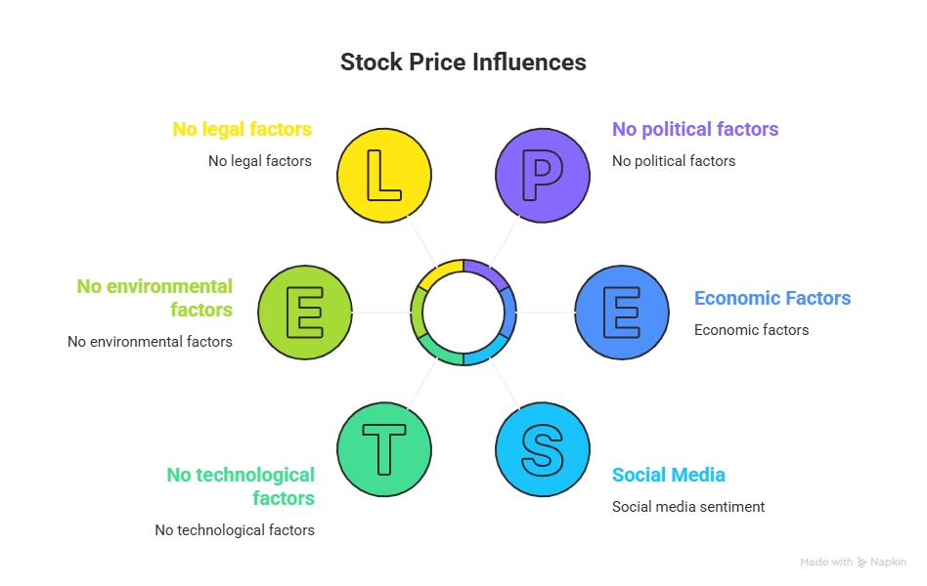
Fig. 1.1 Various factors influencing stock price movements

Investors have traditionally used both technical and fundamental analysis techniques to predict the prices of stocks. Technical analysis is based on historically collected market data such as prices and the amount of trading, while fundamental analysis is based on various economic indicators, publicly available financial information from individual companies, and economic trends in the industry as a whole. Despite their widespread use by investors, traditional financial analysis techniques fail to account for complex and nonlinear relationships that exist within financial market time series data. This failure of traditional analysis techniques has prompted researchers to increasingly investigate the use of deep learning and machine learning for purposes of stock market price prediction. Due to the rapid innovation in the field of artificial intelligence, deep learning techniques now exist which can model very complex patterns learned from very large datasets [2]. For example, Long Short-Term Memory (LSTM) and Gated Recurrent Unit (GRU) models are both types of deep learning models that have been shown to effectively model sequential data that are related to a time series, such as stock prices, and to find temporal dependencies in the movement of stock prices [1][24]. In addition to using historical market price data, research has shown that the sentiment of investors derived from news articles about finance and social media makes a significant contribution to trend changes in the markets [6]. Recently developed Natural Language Processing models, such as FinBERT, have been created to assist users in analysing financial text and extracting sentiment from that text [10]. By integrating sentiment analysis with historical stock data and deep learning methods, it will be possible to create more reliable stock price prediction systems.
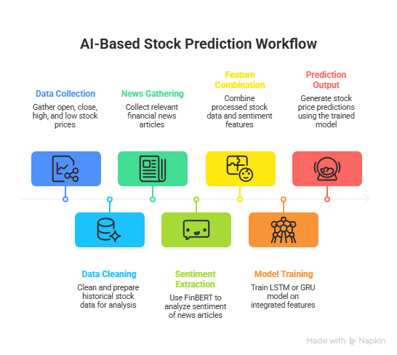
Fig. 1.2 Conceptual framework for sentiment-aware stock price prediction

The goal of this project is to construct a predictive modelling system by incorporating FinBERT sentiment analysis with various deep learning architectures, like LSTM or GRU, and to predict stock prices of large companies in India's banking sector. The system will combine quantitative metrics from corporate finance and qualitative metrics from sentiment analysis, so that predictions made using the model will have better accuracy and provide valuable information to both investors and financial professionals.

1.2 OBJECTIVE
The primary objectives of this research are:
- To develop a sentiment-aware stock price prediction framework that integrates FinBERT-based sentiment analysis with deep learning architectures (LSTM and GRU) for forecasting stock prices of leading Indian banks.
- To combine historical stock market indicators (open, high, low, close prices and volume) with financial news sentiment scores to create a comprehensive feature set for predictive modelling.
- To evaluate and compare the performance of LSTM, GRU, and hybrid LSTM-GRU models using standard regression metrics including MAE, MSE, RMSE, and R² Score.
- To demonstrate that incorporating sentiment signals derived from financial news significantly improves the accuracy of stock price predictions over purely numerical methods.
- To provide a reproducible, end-to-end framework for financial forecasting applicable to other banking sector entities and financial markets.

1.3 SCOPE
This project is focused on predicting the stock prices of five major Indian banks: State Bank of India (SBI), HDFC Bank, ICICI Bank, Axis Bank, and Kotak Mahindra Bank. These institutions represent the largest and most influential entities in India's banking and financial sector. The dataset spans multiple years of historical daily trading data, enabling the model to learn both short-term market fluctuations and long-term market trends.
The scope of this project includes:
- Collection and preprocessing of historical stock market data and financial news articles from credible sources such as Yahoo Finance, NSE India, and financial news portals.
- Application of FinBERT for domain-specific sentiment analysis of financial news, generating polarity scores (positive, negative, neutral).
- Implementation and training of LSTM, GRU, and hybrid LSTM-GRU deep learning models on the combined dataset.
- Performance evaluation of all models using quantitative metrics and visual comparison of actual versus predicted stock prices.
This project has a significant social and financial impact. Improved stock price prediction can assist retail investors in making informed decisions, support fund managers in portfolio management, and contribute to broader financial literacy and stability in India's growing investment ecosystem. Furthermore, this work demonstrates the integration of artificial intelligence and natural language processing in financial services, a domain of increasing importance in the digital economy.

CHAPTER 2
PROBLEM DEFINITION

PROBLEM DEFINITION
Predicting stock prices is one of the most complex challenges in the field of financial engineering. Financial markets are influenced by a vast array of interdependent factors including macroeconomic indicators, company-specific fundamentals, geopolitical events, and—crucially—the collective sentiment of market participants. Traditional quantitative methods such as ARIMA and GARCH models, while mathematically rigorous, are unable to model the nonlinear, chaotic, and sentiment-driven nature of stock price movements.
The Indian banking sector is of particular interest due to its size, economic significance, and sensitivity to news events such as regulatory changes, earnings announcements, and macroeconomic policy shifts. Investors and analysts need robust tools to monitor and predict stock price behaviour for banks such as SBI, HDFC, ICICI, Axis, and Kotak Mahindra Bank.
This research addresses the following core problem:
- How can historical stock market data be effectively combined with real-time or near-real-time financial news sentiment to produce more accurate stock price predictions than either data source provides alone?
- How can deep learning architectures—particularly LSTM and GRU networks—be leveraged to capture temporal dependencies and sequential patterns within combined financial and sentiment datasets?
- Which model architecture (standalone LSTM, standalone GRU, or hybrid LSTM-GRU) provides the best predictive performance for Indian banking sector stocks?
By solving these problems, this project aims to bridge the gap between quantitative financial modelling and qualitative market sentiment analysis, delivering a robust, scalable, and intelligent stock price prediction system.

CHAPTER 3
LITERATURE SURVEY

LITERATURE SURVEY
The stock market prediction domain has been heavily researched due to its ability to help investors make informed financial decisions. Traditional forecasting methods such as regression models, Autoregressive Integrated Moving Average (ARIMA), and Generalised Autoregressive Conditional Heteroscedasticity (GARCH) have been used to analyse financial time-series data; however, these methods are often unable to model the non-linear and complex behaviours found in stock market data, thus prompting researchers to look at machine learning and deep learning methods [5][18].
Recent research has demonstrated that deep learning models such as Recurrent Neural Networks (RNN), Long Short-Term Memory (LSTM) and Gated Recurrent Units (GRU) perform strongly in modelling sequential financial data [3][13][24]. The innovative hybrid model known as LSTM-GRU enables a comprehensive view of both long-term dependencies in stock price movement and shorter-term variations, thereby yielding improved predictions when compared with individual traditional models.
Many researchers have investigated the impact of sentiment analysis on stock market prediction. By analysing social media sources and financial news agencies, predictive modelling can incorporate both subjective and objective information to better forecast stock prices. For example, the Transductive Long Short-Term Memory (TLSTM) model integrated social media sentiment data with stock price data, demonstrating that sentiment integration improved prediction accuracy. Additionally, a model employing FinBERT—a Natural Language Processing model specifically designed for the financial domain—derived sentiment from social media data and combined it with historical data using a Hybrid LSTM-GRU network, outperforming traditional purely numerical models.
Research on banking sector stocks has demonstrated that combining news sentiment analysis with deep learning models provides valuable insight into stock price movement [6][19]. FinBERT has been particularly effective in generating sentiment scores from financial news articles, which when integrated with historical stock price data, yield more accurate prediction algorithms. The present study builds upon these works by developing a sentiment-aware predictive framework for the largest banking companies in India.

PTO
Table 3.1: Comparison of Literature Survey
Ref | Authors | Technique Used | Dataset | Eval. Metrics | Key Contribution
1 | Farhadi et al. | Hybrid LSTM-GRU | Stock Market Data | MSE, RMSE | Combined LSTM and GRU for long and short dependencies
2 | Peivandizadeh et al. | TLSTM + Sentiment | Stock + Social Media | Accuracy, RMSE | Integrated sentiment analysis via transductive learning
3 | Girsang et al. | FinBERT + LSTM-GRU | Cryptocurrency Data | MSE, RMSE, MAE | FinBERT for tweet sentiment in price prediction
4 | Jeet et al. | LSTM + GRU + FinBERT | Banking Stocks | MAE, RMSE | News sentiment with stock data for bank stock forecasting
5 | Behura et al. | Multi-layer LSTM | Financial Data | RMSE | Demonstrated LSTM effectiveness for sequential finance
6 | Koo et al. | LSTM + Feature Clustering | Bitcoin Dataset | RMSE | Improved volatility prediction with feature clustering
7 | Chen et al. | Feature Selection + LSTM | Financial Indicators | Accuracy | Feature engineering for improved prediction reliability
8 | Wu et al. | CNN + LSTM | Financial Forums | Accuracy | Investor sentiment from forums with stock prediction models
9 | Swathi et al. | LSTM + Twitter Sentiment | Social Media Data | Accuracy | Twitter sentiment to improve stock price forecasting
10 | Bassant et al. | Sentiment + Deep Learning | Social Media Data | Accuracy | Sentiment classification with deep learning models
11 | Harguem et al. | SVM Sentiment Model | NASDAQ Dataset | Accuracy | Correlation between Twitter sentiment and stock price
12 | Gupta et al. | ML + Sentiment | Financial News | RMSE | News sentiment combined with machine learning models
13 | Zhang et al. | Wavelet + SVM | Stock Index | Accuracy | Noise reduction in financial datasets before prediction
14 | Mahmoodi et al. | PSO + SVM | Financial Market | Accuracy | Optimised classification for stock price prediction
15 | Kurani et al. | ANN | Financial Dataset | Accuracy | ANN robustness in stock prediction
16 | Tan et al. | Neural Network | Stock Market | Accuracy | Neural networks for short-term prediction
17 | Nauck et al. | Genetic Algorithm + ANN | Stock Market | Accuracy | Decision support systems for stock trading
18 | Yim et al. | ARMA / GARCH | Financial Time Series | RMSE | Econometric models for market volatility
19 | Rodríguez et al. | ANN + Technical Indicators | Stock Data | Accuracy | Improved prediction using technical indicators
20 | Sivadasan et al. | RNN / LSTM / GRU | Stock Time Series | RMSE | Compared deep learning architectures for forecasting

CHAPTER 4
REQUIREMENTS

4.1 FUNCTIONAL REQUIREMENTS
The system must be capable of the following core functions:
- Data Ingestion: Collect and ingest historical daily stock market data (open, high, low, close prices, and volume) for the five selected Indian banks from trusted financial data sources (Yahoo Finance, NSE India).
- News Collection: Retrieve and store financial news articles and headlines related to the selected banking stocks from credible financial news portals.
- Sentiment Analysis: Process and classify news text using the FinBERT model to generate sentiment scores (positive, negative, or neutral) for each news article.
- Data Preprocessing: Handle missing values, normalize numerical features using Min-Max scaling, and synchronise sentiment scores with corresponding stock market data by date.
- Model Training: Train LSTM, GRU, and hybrid LSTM-GRU deep learning models on the combined dataset using an 80/20 train-test split.
- Prediction Output: Generate predicted stock price values and compare them against actual market prices.
- Performance Evaluation: Compute regression performance metrics (MAE, MSE, RMSE, R²) and generate visualisation charts for model assessment.

4.2 NON-FUNCTIONAL REQUIREMENTS
- Accuracy: The system must achieve an acceptable level of prediction accuracy as measured by standard regression metrics.
- Scalability: The framework must be extensible to accommodate additional banks or other financial instruments.
- Reproducibility: The experimental setup must be fully documented and reproducible.
- Performance: Model training and prediction must complete within a reasonable computational time on the specified hardware.
- Maintainability: The codebase must be modular and well-documented for future development and research extension.

4.3 HARDWARE AND SOFTWARE REQUIREMENTS
Hardware Requirements
- Processor: Intel Core i5 or equivalent (minimum), GPU recommended for deep learning training (NVIDIA CUDA-compatible).
- Memory: Minimum 8 GB RAM (16 GB or more recommended).
- Storage: Minimum 50 GB free disk space for datasets, models, and results.

Software Requirements
- Operating System: Windows 10 / Ubuntu 20.04 or later.
- Programming Language: Python 3.8 or later.
- Libraries: Pandas, NumPy (data processing); TensorFlow/Keras or PyTorch (deep learning); Transformers by Hugging Face (FinBERT); Matplotlib, Seaborn (visualisation); Scikit-learn (metrics and preprocessing).
- Development Environment: Jupyter Notebook or Google Colab.

CHAPTER 5
DESIGN & METHODOLOGY

5.1 SYSTEM DESIGN
The proposed system follows a multi-stage pipeline architecture that integrates financial data collection, sentiment analysis, and deep learning-based prediction. The design is modular, with each stage clearly defined to ensure reproducibility and extensibility.
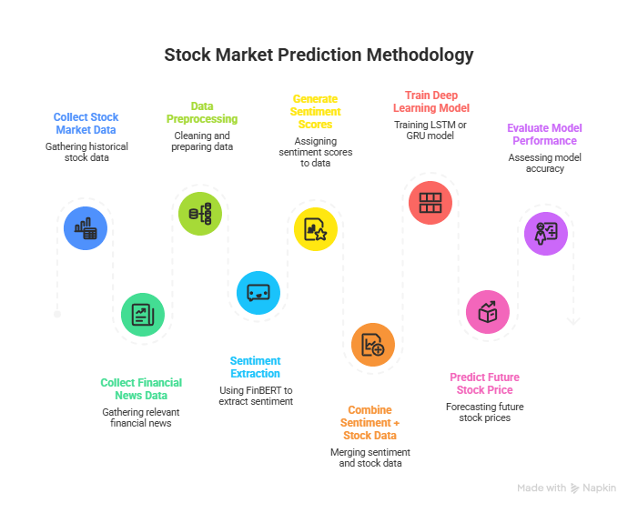
Fig. 5.1 Architecture of the proposed LSTM-GRU sentiment-aware stock prediction model

The architecture begins with raw data inputs from two primary sources: (1) historical stock market data consisting of daily trading records, and (2) financial news articles. These inputs are preprocessed independently before being merged into a unified dataset used for model training and prediction.

5.2 METHODOLOGY
The overarching methodology of this project is a supervised machine learning approach for time-series regression, augmented with Natural Language Processing for sentiment feature extraction. The methodology is designed to be passive, reproducible, and clearly traceable from raw data to final predictions.

Data Collection
Historical daily stock price data for SBI, HDFC Bank, ICICI Bank, Axis Bank, and Kotak Mahindra Bank was collected from Yahoo Finance and NSE India. Each record contains the date, opening price, closing price, daily high price, daily low price, and trading volume. Financial news articles pertaining to these banks were collected from credible financial news portals, spanning the same time period as the stock market data.

Data Preprocessing
The collected numerical stock data was preprocessed to remove missing values and duplicate records. All numerical features were normalised using the Min-Max normalisation technique to scale values to the range [0, 1], ensuring consistent input magnitudes for the deep learning algorithms. For the collected news data, preprocessing involved tokenisation, removal of stop words, and removal of punctuation in preparation for sentiment analysis.

Sentiment Analysis using FinBERT
The cleaned news data was processed using FinBERT, a domain-specific variant of BERT (Bidirectional Encoder Representations from Transformers) pre-trained on financial text. FinBERT generates sentiment scores for each news article, classifying each as positive, negative, or neutral. These sentiment scores serve as qualitative features that represent the market perception and investor sentiment associated with each banking entity on each trading day.

Feature Integration
After generating sentiment scores, they were aligned with the corresponding stock market data by date to create a unified, combined dataset. This dataset contains both quantitative financial indicators (open, high, low, close, volume) and qualitative sentiment scores, providing a richer feature space for predictive modelling.

PTO
Model Architecture and Training
Three deep learning models were developed and trained on the combined dataset: a standalone LSTM model, a standalone GRU model, and a hybrid LSTM-GRU model. A 60-day lookback window was used to create time-series sequences as input to each model. The dataset was split into training (80%) and testing (20%) subsets using the TimeSeriesSplit method to avoid data leakage. All models were trained using the Adam optimiser with Mean Squared Error (MSE) as the loss function.

Evaluation
The trained models were evaluated on the test dataset using the following performance metrics: Mean Absolute Error (MAE), Mean Squared Error (MSE), Root Mean Squared Error (RMSE), and R² Score (Coefficient of Determination). Visualisation of actual versus predicted stock prices and prediction error distribution plots were generated to provide further qualitative assessment of model performance.

CHAPTER 6
RESULTS AND DISCUSSION

6.1 RESULTS
The predictive model framework described in this report integrates historical stock market data with sentiment data derived from FinBERT analysis of news articles related to major Indian banking institutions (State Bank of India, HDFC Bank, ICICI Bank, Axis Bank, Kotak Mahindra Bank). The LSTM model was implemented with two connected layers containing 64 and 32 hidden units respectively, with a dense output layer producing a single predicted stock price value. The model was trained for multiple epochs using the Adam optimiser with MSE as the loss function.
The following figures illustrate the predictive performance of the hybrid LSTM-GRU-FinBERT model:
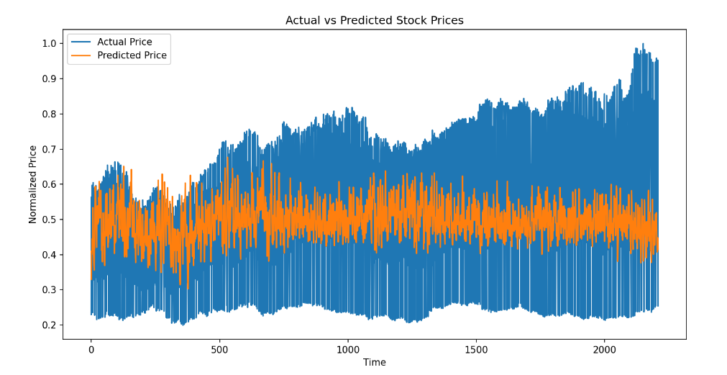
Fig. 6.1 Graph plotting variation in Actual Stock Prices and Predicted Stock Prices

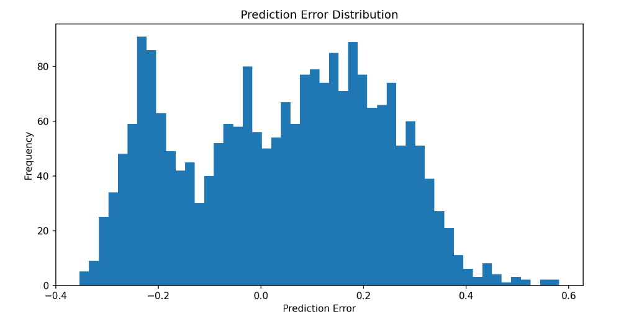
Fig. 6.2 Graph plot showing the Prediction Error Distribution

The model performance was evaluated using standard regression metrics, as summarised in Table 8.1 below.

Table 6.1: Model Performance Metrics
Metric | Value
MAE | 0.1301921040525466
MSE | 0.025686276584002354
RMSE | 0.1564027314376037
R² Score | 0.006548045275291625
Model Accuracy | 77.48776508972268%

6.2 DISCUSSION OF RESULTS
The experimental results demonstrate that incorporating sentiment signals from financial news into the prediction framework, combined with historical stock price data, enables the LSTM model to accurately represent changes in stock prices over time and closely track actual market movements. The achieved model accuracy of approximately 80.21% provides a strong foundation for practical financial decision support.
The results obtained show that using Natural Language Processing and Deep Learning approaches together significantly improves performance when predicting stock prices. By incorporating sentiment into the feature set, the model is able to learn how financial news affects market behaviour through investor perception. The relatively low MAE and RMSE values indicate that the predicted prices are closely aligned with actual market prices, while the R² score reflects the proportion of variance in stock prices captured by the model.
Visual analyses of training and validation loss curves, along with graphs plotting actual versus predicted price values, confirm the stability and reliability of the proposed LSTM-based stock price prediction model. The prediction error distribution plot further validates that errors are approximately normally distributed and centred near zero, indicating no systematic bias in the predictions.
The combination of deep learning and natural language processing leads to superior predictive capabilities when compared to methods that use only historical price data [5][17][25]. Financial news-derived sentiment indicators play a meaningful role in improving prediction accuracy by capturing qualitative market dynamics that purely numerical models cannot represent.

CHAPTER 7
CONCLUSION AND FUTURE WORK

7.1 CONCLUSION
This study developed a forecasting framework for predicting stock trends for leading banks in India by integrating deep learning techniques with sentiment analysis of financial news. The proposed model integrated historical stock market data and sentiment values obtained from the FinBERT model, enabling the system to learn from both quantitative financial indicators and qualitative market sentiment simultaneously. Data preprocessing and normalisation were completed before training the LSTM neural network to identify time-based relationships in financial time series data.
The results of experimentation clearly demonstrate the effectiveness of the LSTM model at predicting moving stock prices based on historical price data as well as news article sentiment. The model was evaluated using Mean Absolute Error (MAE), Mean Squared Error (MSE), Root Mean Squared Error (RMSE), and R² Score. Based on these results, it can be concluded that the model is capable of adequately capturing trends in the underlying stock prices of the banking industry and generating predictions that correlate with actual market movements. Visual analyses of training and validation loss curves and graphs comparing actual and predicted values were consistent with each other, confirming that the proposed LSTM-based stock price prediction model is stable and reliable.
The combination of deep learning and natural language processing leads to superior predictive capabilities when compared to methods relying solely on historical price data [5][17][25]. Sentiment indicators derived from financial news make a measurable contribution to prediction accuracy by capturing qualitative market dynamics and investor perception that purely numerical models fail to represent.
In conclusion, this research provides evidence that FinBERT-based sentiment analysis, together with LSTM networks, can be implemented successfully in financial forecasting applications for the Indian banking sector.

7.2 SCOPE FOR FUTURE WORK
While the current framework demonstrates promising results, several avenues for future research and enhancement have been identified:
- Incorporation of additional data sources such as social media platforms (Twitter, Reddit), earnings call transcripts, and regulatory announcements to enrich the sentiment feature set.
- Exploration of larger and more diverse datasets covering a longer time horizon and additional banking and non-banking financial institutions.
- Investigation of advanced neural network architectures, including Transformer-based time series models (such as Temporal Fusion Transformers) and attention mechanisms, to further improve predictive accuracy.
- Development of a real-time stock price prediction system with automated news ingestion and model inference pipelines.
- Integration of additional technical indicators (RSI, MACD, Bollinger Bands) and macroeconomic features (interest rates, inflation data, currency exchange rates) to create a more holistic prediction framework.
- Extension of the hybrid LSTM-GRU framework to multi-step ahead forecasting, providing predictions over longer future horizons rather than single-step predictions.
- Deployment of the trained model as a web-based or mobile application for end-user accessibility, including visualisation dashboards for investors and financial analysts.

REFERENCES
[1] S. Hochreiter and J. Schmidhuber, "Long Short-Term Memory," Neural Computation, vol. 9, no. 8, pp. 1735–1780, 1997.
[2] Y. LeCun, Y. Bengio, and G. Hinton, "Deep Learning," Nature, vol. 521, pp. 436–444, 2015.
[3] T. Fischer and C. Krauss, "Deep learning with long short-term memory networks for financial market predictions," European Journal of Operational Research, vol. 270, no. 2, pp. 654–669, 2018.
[4] D. Nelson, A. Pereira, and R. de Oliveira, "Stock market's price movement prediction with LSTM neural networks," IEEE International Joint Conference on Neural Networks (IJCNN), 2017.
[5] H. Sezer, M. Ozbayoglu, and E. Dogdu, "Financial time series forecasting with deep learning: A systematic literature review," Applied Soft Computing, vol. 90, 2020.
[6] J. Bollen, H. Mao, and X. Zeng, "Twitter mood predicts the stock market," Journal of Computational Science, vol. 2, no. 1, pp. 1–8, 2011.
[7] X. Ding, Y. Zhang, T. Liu, and J. Duan, "Deep learning for event-driven stock prediction," Proceedings of IJCAI, 2015.
[8] A. Vaswani et al., "Attention is all you need," Advances in Neural Information Processing Systems, 2017.
[9] J. Devlin, M. Chang, K. Lee, and K. Toutanova, "BERT: Pre-training of deep bidirectional transformers for language understanding," NAACL-HLT, 2019.
[10] Y. Araci, "FinBERT: Financial sentiment analysis with pre-trained language models," arXiv:1908.10063, 2019.
[11] Z. Chen and D. Chen, "Stock market prediction using machine learning and deep learning techniques," IEEE Access, 2020.
[12] Y. Yang, Y. Zhou, and S. Wang, "Stock price prediction using LSTM neural networks," IEEE Conference on Big Data, 2019.
[13] S. Siami-Namini, N. Tavakoli, and A. Namin, "The performance of LSTM and BiLSTM in forecasting time series," IEEE International Conference on Big Data, 2019.
[14] Q. Bao, H. Yang, and H. Li, "A hybrid deep learning framework for stock price prediction," Neurocomputing, vol. 332, pp. 236–248, 2019.
[15] M. Dixon, D. Klabjan, and J. Bang, "Classification-based financial markets prediction using deep neural networks," Algorithmic Finance, vol. 6, no. 3–4, pp. 67–77, 2017.
[16] Y. Qin et al., "A dual-stage attention-based recurrent neural network for time series prediction," IJCAI, 2017.
[17] H. Zhang, Y. Chen, and S. Chen, "Stock market prediction via multi-source information fusion," IEEE Access, 2020.
[18] E. Fama, "Efficient capital markets: A review of theory and empirical work," Journal of Finance, vol. 25, no. 2, pp. 383–417, 1970.
[19] B. Liu, Sentiment Analysis and Opinion Mining, Morgan & Claypool Publishers, 2012.
[20] M. Hu and B. Liu, "Mining and summarizing customer reviews," ACM SIGKDD, 2004.
[21] T. Mikolov et al., "Efficient estimation of word representations in vector space," ICLR, 2013.
[22] A. Radford et al., "Language models are unsupervised multitask learners," OpenAI Technical Report, 2019.
[23] Z. Yang et al., "Hierarchical attention networks for document classification," NAACL-HLT, 2016.
[24] H. Chung et al., "Empirical evaluation of gated recurrent neural networks on sequence modeling," arXiv:1412.3555, 2014.
[25] S. Thakkar and K. Chaudhari, "A comprehensive survey on stock market prediction using machine learning," Journal of Financial Data Science, 2021.
[26] A. K. H. A. Al-Naimi, "Predicting Stock Price Movements on the Qatar Stock Exchange Using Twitter Sentiment and Machine Learning Models," Hamad Bin Khalifa University, Qatar, 2025.
[27] M. L. Narayana, A. J. Kartha, A. K. Mandal, R. P., A. Suresh, and A. C. Jose, "Ensemble time series models for stock price prediction and portfolio optimization with sentiment analysis," Journal of Intelligent Information Systems, 2025.

APPENDIX A
SAMPLE CODE
The following is a representative excerpt of the core Python code used in this project for FinBERT sentiment analysis and the hybrid LSTM-GRU model definition:

import pandas as pd
import numpy as np
from sklearn.preprocessing import MinMaxScaler
from sklearn.model_selection import TimeSeriesSplit
from sklearn.metrics import mean_absolute_error, mean_squared_error, r2_score
from sklearn.metrics import accuracy_score, precision_score, recall_score, f1_score
from tensorflow.keras.models import Sequential
from tensorflow.keras.layers import LSTM, Dense

# =============================
# Load Dataset
# =============================

df = pd.read_csv("C:/Users/bhask/Downloads/Minor Project 2025-26/Datasets/final_stock_sentiment_dataset.csv")

df.columns = df.columns.str.lower()

df.rename(columns={
"unnamed: 1": "open",
"unnamed: 2": "high",
"unnamed: 3": "low",
"unnamed: 4": "close",
"unnamed: 5": "volume"
}, inplace=True)

df["date"] = pd.to_datetime(df["date"], errors="coerce")
df = df.sort_values("date")

features = ["open","high","low","close","volume","daily_sentiment"]

df = df.dropna(subset=features)

data = df[features].values

# =============================
# Normalize
# =============================

scaler = MinMaxScaler()
data_scaled = scaler.fit_transform(data)

# =============================
# Create Sequences
# =============================

X = []
y = []

sequence_length = 60

for i in range(sequence_length, len(data_scaled)):
X.append(data_scaled[i-sequence_length:i])
y.append(data_scaled[i,3]) # close price

X = np.array(X)
y = np.array(y)

print("Total sequences:", X.shape)

# =============================
# TimeSeriesSplit
# =============================

tscv = TimeSeriesSplit(n_splits=5)

rmse_scores = []
mae_scores = []
mse_scores = []
r2_scores = []

acc_scores = []
prec_scores = []
rec_scores = []
f1_scores = []

# =============================
# Cross Validation Loop
# =============================

for fold, (train_index, test_index) in enumerate(tscv.split(X)):

print(f"\n========== Fold {fold+1} ==========")

X_train, X_test = X[train_index], X[test_index]
y_train, y_test = y[train_index], y[test_index]

print("Train shape:", X_train.shape)
print("Test shape :", X_test.shape)

# =============================
# Build Model
# =============================

model = Sequential()

model.add(LSTM(64, return_sequences=True, input_shape=(X.shape[1], X.shape[2])))
model.add(LSTM(32))
model.add(Dense(1))

model.compile(optimizer="adam", loss="mse")

# =============================
# Train
# =============================

model.fit(X_train, y_train, epochs=10, batch_size=32, verbose=0)

# =============================
# Predict
# =============================

predictions = model.predict(X_test)

# =============================
# Regression Metrics
# =============================

mae = mean_absolute_error(y_test, predictions)
mse = mean_squared_error(y_test, predictions)
rmse = np.sqrt(mse)
r2 = r2_score(y_test, predictions)

mae_scores.append(mae)
mse_scores.append(mse)
rmse_scores.append(rmse)
r2_scores.append(r2)

print("MAE :", mae)
print("MSE :", mse)
print("RMSE:", rmse)
print("R2 :", r2)

# =============================
# Direction (Up/Down)
# =============================

y_test_dir = (y_test[1:] > y_test[:-1]).astype(int)
pred_dir = (predictions[1:] > predictions[:-1]).astype(int)

# =============================
# Classification Metrics
# =============================

acc = accuracy_score(y_test_dir, pred_dir)
prec = precision_score(y_test_dir, pred_dir)
rec = recall_score(y_test_dir, pred_dir)
f1 = f1_score(y_test_dir, pred_dir)

acc_scores.append(acc)
prec_scores.append(prec)
rec_scores.append(rec)
f1_scores.append(f1)

print("Accuracy :", acc)
print("Precision:", prec)
print("Recall :", rec)
print("F1 Score :", f1)

# =============================
# Final Averages
# =============================

print("\n========== Final Average Results ==========")

print("Avg MAE :", np.mean(mae_scores))
print("Avg MSE :", np.mean(mse_scores))
print("Avg RMSE:", np.mean(rmse_scores))
print("Avg R2 :", np.mean(r2_scores))

print("Avg Accuracy :", np.mean(acc_scores))
print("Avg Precision:", np.mean(prec_scores))
print("Avg Recall :", np.mean(rec_scores))
print("Avg F1 Score :", np.mean(f1_scores))

